
FACULTY OF ENGINEERING
DIPLOMA ENGINEERING
DEPARTMENT OF COMPUTER ENGINEERING
SOFTWARE ENGINEERING (DE103304)

Unit-1
Software Process Models
- Defining Software:
Software is the “collection of computer programs, procedures, rules, associated documents and concerned data with the operation of data processing system”.
It also includes representation of pictorial, video and audio information. Software’s are of two types.
- System Software
- Applicatin Software
- System Software
oIt is responsible for controlling, integrating the hardware components of a system so the software and the users can work with them.
Example: Operating System.
- Application Software
  - It is used to accomplish some specific task
  - It should be collection of small programs.
  - Example: Microsoft Word, Excel etc.
- Embedded Software 
 o Embedded software is a piece of software that is embedded in hardware or non-PC devices.
  - It is written specifically for the particular hardware that it runs on and usually has processing and memory constraints because of the device’s limited computing capabilities.
  - Examples of embedded software include those found in dedicated GPS devices, factory robots, some calculators and even modern smart watches.
- Web Application
  - A web-application is an application program that is usually stored on a remote server, and users can access it through the use of Software known as web-browser.
  - It is a type of computer program that usually runs with the help of a web browser and also uses many web technologies to perform various tasks on the internet.

- Artificial intelligence Software
- Artificial intelligence is the simulation of human intelligence processes by machines, especially computer systems.
- Specific applications of AI include expert systems, natural language processing, speech recognition and machine vision.
- Artificial Intelligence (AI) Software is a computer program which mimics human behavior by learning various data patterns and insights.
  - Top features of AI software include Machine Learning, Speech&VoiceRecognition, and Virtual Assistant etc.

- Software Characteristics
- The characteristics of software decide whether the software is good or bad.
- Understandability
✓ S/Wshould be easy to understand
✓ It should be efficient to use.
- Cost
✓Software should be cost effective as per its usage.
- Maintainability
✓Software should be easily maintainable and modifiable in future.
- Modularity
✓Software should have modular approach so it can be handled easily for testing.
- Functionality
✓Software should be functionally capable to meet user requirements.
- Reliability
✓It should have the capability to provide failure-free service.
- Portability
✓Software should have the capability to be adapted for different environments.
Correctness
Software should be correct as per its requirements.
Documentation
Software should be properly documented so that we can re-refer it in future.

Software Development Life Cycle
- Every system has a life cycle.
- It begins when a problem is recognized, after then system is developed, grows until maturity and then maintenance needed due to change in the nature of the system. So, it died and new system or replacement of it taken place.
- SDLC is a framework that describes the activities performed at each stage of a software development project.

- Different Software life cycle models

- Waterfall model
  - Incremental Process Model
  - Prototype Model
  - Spiral Model
  - V- Model
- Layers of Software Engineering: 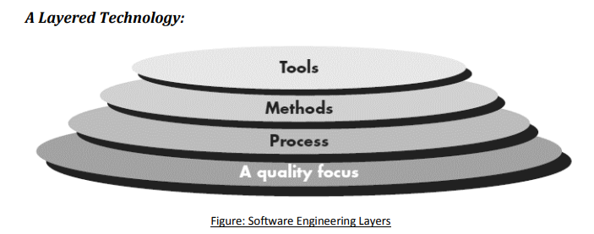
- 1. Quality Focus (Foundation)
- Meaning: Quality is the foundation (base) of Software Engineering.
- Explanation:

- Every software company wants to develop high-quality software.
- Good quality means:
  - Fewer errors (bugs)
  - Better performance
  - Customer satisfaction
- The main goal of software engineering is to produce quality software.

2. Process

Meaning:A Process is a step-by-step plan for developing software.

Easy Explanation:
The process tells developers:
- What to do
- When to do it
- How to do it
It helps in:
- Managing the project
- Completing work on time
- Maintaining software quality
- Handling changes properly

3. Methods
Methods are the technical techniques used to build software.

Easy Explanation:
Methods help developers perform different tasks such as:
- Communicating with customers
- Collecting requirements
- Designing software
- Writing code
- Testing the software
- Maintaining the software
Methods explain how to develop software correctly.

4. Tools

Meaning:
Tools are software applications that help developers do their work faster and more accurately.

Easy Explanation:
Tools help in:
- Writing code
- Designing software
- Testing programs
- Finding errors
- Managing projects
When many tools work together, they form a CASE (Computer-Aided Software Engineering) system.

Examples of Tools:
- Visual Studio
- Eclipse
- NetBeans
- Git
- JUnit
Tools make software development easier, faster, and more efficient.

Process & Generic Process Model
A software process is a set of activities, actions, and tasks that are performed to create a software product.
These activities, actions, and tasks are organized within a framework or model. The framework defines the order of the tasks and shows how they are connected to each other and to the overall software development process.

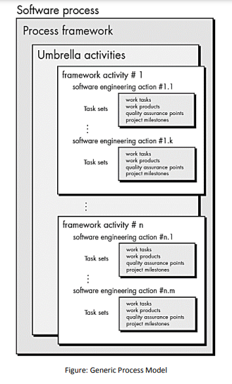

Generic Process Model
A software process is a series of steps used to develop a software product. It includes different activities, actions, and tasks that help in creating the software.
All these activities and tasks follow a framework or model. This framework shows what work should be done, in what order it should be done, and how each task is connected to the others.
Umbrella Activities:
A software engineering process includes umbrella activities, which are additional activities performed throughout the entire software project. These activities help the team manage the project, maintain quality, handle changes, and reduce risks.
This activity helps the software team monitor the project's progress. If the project is falling behind schedule, the team can take corrective actions to complete it on time.
Risk management identifies and analyzes problems that might affect the project or the quality of the software. It helps the team prepare solutions before problems occur.
Software Quality Assurance (SQA) ensures that the software meets the required quality standards. It checks whether the software is reliable, correct, and works properly.
Technical reviews examine the software and related documents to find and fix errors early. This s
Prescriptive Process Models
Prescriptive process models were originally proposed to bring order to the chaos of software development.
Traditional models have brought a certain amount of useful structure to software engineering work and have provided a reasonably effective road map for software teams.
Following are prescriptive process models:
̶ Waterfall model
̶ Incremental Model
- RAD Model
̶ Evolutionary Process Model
- Prototype Model
- Spiral Model
- Concurrent Process Model
Waterfall Process Model
The Waterfall Model is one of the oldest software development models. It follows a step-by-step process, where each phase is completed before moving to the next. The process starts with gathering customer requirements, then moves to planning, designing, coding, testing, deployment, and finally maintenance.

Limitations:
- Requirements should be clear and should not change during development.
- Each phase must be completed before starting the next phase.
- It cannot easily handle changing requirements.
- Customers cannot use the software until it is completely finished.
- After development, only maintenance is expected.
- Errors found at the end are costly and difficult to fix.
- Some team members may have to wait until the previous phase is completed.
- It is suitable only when requirements are well understood and changes are very few.

When to Use the Waterfall Model?
- Requirements are clear, fixed, and well understood.
- The product definition is stable.
- The technology to be used is well known.
- There are no unclear or changing requirements.
- Skilled team members and enough resources are available.

Incremental Model
- The incremental model is also referred as the successive version of waterfall model using incremental approach.
- In this model, the system is broken down into several modules which can be incrementally implemented and delivered.
- First develop the core product of the system.
- The core product is used by customers to evaluate the system.
- The initial product skeleton is refined into increasing levels of capability: by adding new functionality in successive version.
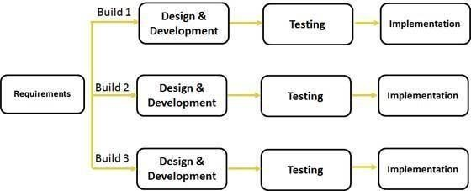

- Incremental Model – Advantages

  - Each successive version performing more useful work than previous version.
  - The core modules get tested thoroughly, there by reducing chance of error in final product.
The model is more flexible and less costly to change the scope and requirements.
  - User gets a chance to experiment with partially developed software.
  - Feedback providing at each increment is useful for determining the better final product.
- Incremental Model – Disadvantages.
- Sometimes it is difficult to subdivide problems into functional unit.
- Model can be used for very large problems.
- It needs good planning and design.
•Incremental Model – When to use?
- The incremental model is used when the problem is very large and user requirements are not well specified at initial stage.
- This model is used when the system is modularized and all the requirements are well defined.

Spiral Model

- This model is proposed by Boehm in 1986.
- In application development, spiral model uses fourth generation (4GL) languages and development tools.
- In pictorial view, this model appears like a spiral with many loops. •Each loop of the spiral represents a phase of the software process.
  - The innermost loop might be concerned with system feasibility ✓The next loop with system requirement definition.
  - The next one with system design and so on.
  - Each loop in the spiral split into four sectors. (quadrants)

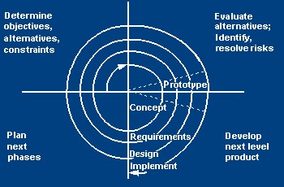
- 1st Quadrant: Determine Objectives
- 2nd Quadrant: Identify and resolve risks
- 3rd Quadrant: Develop next level product

- 4th Quadrant: Review and planning
- In spiral model, at any point, Radius represents: cost and Angular dimension represent: progress of the current phase.
- Spiral Model – Advantages
    - It is more flexible, as we can easily deal with changes.
    - Due to user involvement, user satisfaction is improved.
    - New idea and functionality can be easily added at later stage.
- Spiral Model – Disadvantages
    - It is applicable for large problem only.
    - It can be more costly to use.
    - It is more complex to understand.
    - More number of documents are needed as more number of spirals.

- Spiral Model – When to Use?
    - Used when medium to high risk projects.
    - When user are unsure for their needs.
    - When requirement are complex.

Prototype Model
- Prototype is a working physical system or subsystem.
- Prototype is nothing but a tip implementation of a system.
- In this model, before starting actual development, a working prototype of the system should be built first.
- A prototype is actually a partial developed product.
- Compared to the actual software, a prototype usually have,
  - Limited functional capabilities
  - Low reliability
  - Inefficient performance

- Prototype usually built using several shortcuts, and these shortcuts might be inefficient, inaccurate or dummy functions.
- Prototype model is very useful in developing GUI part of system.

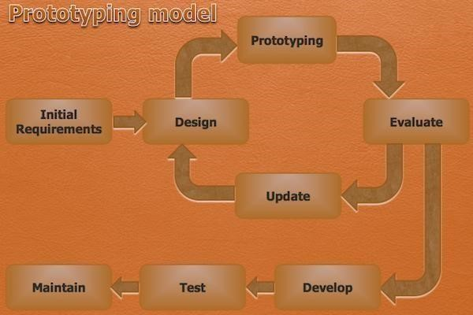

In working of the prototype model, product development starts with initial requirements gathering phase.
- Then, quick design is carried out and prototype is built.
- The developed prototype is then submitted to the customer for his evaluation.
- Based on customer feedback, the requirements are refined and prototype is modified.
- This cycle of obtaining customer feedback and modifying the prototype continues till the customers approve the prototype.
- The actual system is developed using different phases of iterative waterfall model.

- Prototype Model – Advantages

  - A partial product is built at initial stage, so customers can get a chance to have a look of the product.
  - New requirements can be accommodate easily.
  - Quicker user feedback is available for better solution.
  - As the partial product is evaluated by the end users, more chance of user satisfaction.
- Prototype Model – Disadvantages
  - The code for prototype model is usually thrown way. So wasting of time is there.
  - The construction cost of developing the prototype is very high.
  - If the end user is not satisfied with the initial prototype, then he/she may loose interest in the final product.

- Prototype Model – When to Use?
  - This model is used when the desired system needs to have a lot of interactions with end users. ✓This type of model generally used in GUI type of development.

- Prototype Model – Disadvantages
  - The code for prototype model is usually thrown way. So wasting of time is there.
  - The construction cost of developing the prototype is very high.
  - If the end user is not satisfied with the initial prototype, then he/she may loose interest in the final product.

- Prototype Model – When to Use?
  - This model is used when the desired system needs to have a lot of interactions with end users.
  - This type of model generally used in GUI type of development.

V-Model
- The SDLC V-Model is a type of Software Development Life Cycle (SDLC).
- It is a method that includes testing and validation alongside each development phase.
- It creates a structure like the letter 'V,' which includes various phases that we will discuss in detail.
Phases of SDLC V-Model
- The V-Model, which includes the Verification and Validation it is a structural approach to software development.
- The following are the different Phases of the V-Model of the SDLC.
1.0 V-Model Verification Phases
- This is where the process begins. The first step is to gather and understand the customer’s needs for the software. The goal is to define the scope of the project clearly to make sure everyone is on the same page.
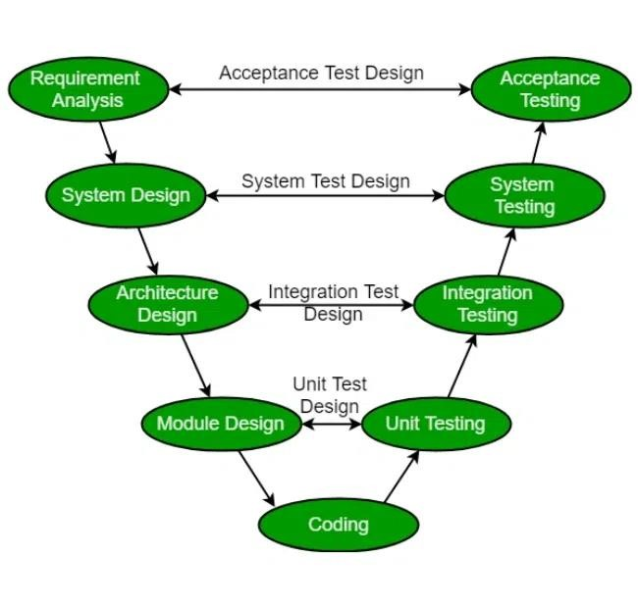
1. Business Requirement Analysis
- This is the first step of the designation of the development cycle where product requirement needs to be cured from the customer's perspective. These phases include proper communication with the customer to understand their requirements.
- These are the very important activities that need to be handled properly, as most of the time customers do not know exactly what they want, and they are not sure about it at that time then we use an acceptance test design planning which is done at the time of business requirement it will be used as an input for acceptance testing.

  - System Design
- In this phase, the overall structure of the software is planned out. The team develops both the high-level design (how the system will be structured) and detailed design (how the individual components will work).
- Design of the system will start when the overall we are clear with the product requirements, and then need to design the system completely. This understanding will be at the beginning of complete under the product development process. these will be beneficial for the future execution of test cases.
  - Architectural Design
- In this stage, architectural specifications are comprehended and designed. Usually, several technical approaches are put out, and the ultimate choice is made after considering both the technical and financial viability. The system architecture is further divided into modules that each handle a distinct function. Another name for this is High-Level Design (HLD).
- At this point, the exchange of data and communication between the internal modules and external systems are well understood and defined. During this phase, integration tests can be created and documented using the information provided.
  - Module Design
- This phase, known as Low-Level Design (LLD), specifies the comprehensive internal design for every system module. Compatibility between the design and other external systems as well as other modules in the system architecture is crucial. Unit tests are a crucial component of any development process since they assist in identifying and eradicating the majority of mistakes and flaws at an early stage. Based on the internal module designs, these unit tests may now be created.
  - Coding Phase
- This is where the software is actually built. Developers write the code based on the design created in the previous phase.
- The Coding step involves writing the code for the system modules that were created during the Design phase. The system and architectural requirements are used to determine which programming language is most appropriate.
- The coding standards and principles are followed when performing the coding. Before the final build is checked into the repository, the code undergoes many code reviews and is optimized for optimal performance.
2. V-Model Validation Phases
- It involves dynamic analysis techniques (functional, and non-functional), and testing done by executing code. Validation is the process of evaluating the software after the completion of the development phase to determine whether the software meets the customer's expectations and requirements.
1. Unit Testing
- In Unit testing, unit Test Plans are developed during the module design phase. These Unit Test Plans are executed to eliminate bugs in code or unit level.
2. Integration testing
- After completion of unit testing Integration testing is performed. In integration testing, the modules are integrated and the system is tested. Integration testing is performed in the Architecture design phase. This test verifies the communication of modules among themselves.
3. System Testing
- System testing tests the complete application with its functionality, inter-dependency, and communication. It tests the functional and non-functional requirements of the developed application.
4. User Acceptance Testing (UAT)
- User Acceptance Testing (UAT) is performed in a user environment that resembles the production environment. UAT verifies that the delivered system meets the user's requirement and the system is ready for use in the real world.
Industrial Challenge of V-Model
- As the industry has evolved, the technologies have become more complex, increasingly faster, and forever changing, however, there remains a set of basic principles and concepts that are as applicable today as when IT was in its infancy.
- Accurately define and refine user requirements.
- Design and build an application according to the authorized user requirements.
- Validate that the application they had built adhered to the authorized business requirements.

Agile Model
- The meaning of Agile is swift or versatile. “Agile process model" refers to a software development approach based on iterative development.
- Agile methods break tasks into smaller iterations, or parts do not directly involve long term planning.
- The project scope and requirements are laid down at the beginning of the development process.
- Plans regarding the number of iterations, the duration and the scope of each iteration are clearly defined in advance.

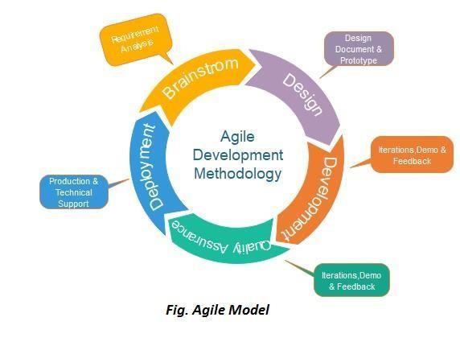
Phases of Agile Model:
- Following are the phases in the Agile model are as follows:
- Requirements gathering
- Design the requirements
- Construction/ iteration
- Testing/ Quality assurance
- Deployment
- Feedback

- Requirements gathering: In this phase, you must define the requirements. You should explain business opportunities and plan the time and effort needed to build the project. Based on this information, you can evaluate technical and economic feasibility.
- Design the requirements: When you have identified the project, work with stakeholders to define requirements. You can use the user flow diagram or the high-level UML diagram to show the work of new features and show how it will apply to your existing system.
- Construction/ iteration: When the team defines the requirements, the work begins. Designers and developers start working on their project, which aims to deploy a working product. The product will undergo various stages of improvement, so it includes simple, minimal functionality.

- Testing: In this phase, the Quality Assurance team examines the product's performance and looks for the bug.

- Deployment: In this phase, the team issues a product for the user's work environment.

- Feedback: After releasing the product, the last step is feedback. In this, the team receives feedback about the product and works through the feedback.

When to use the Agile Model?
oWhen frequent changes are required. oWhen a highly qualified and experienced team is available. oWhen a customer is ready to have a meeting with a software team all the time. oWhen project size is small.

Advantage(Pros) of Agile Method:
  - Frequent Delivery
  - Face-to-Face Communication with clients.
  - Efficient design and fulfils the business requirement.
  - Anytime changes are acceptable.
  - It reduces total development time.

Disadvantages (Cons) of Agile Model:
  - Due to the shortage of formal documents, it creates confusion and crucial decisions taken throughout various phases can be misinterpreted at any time by different team members.
  - Due to the lack of proper documentation, once the project completes and the developers allotted to another project, maintenance of the finished project can become a difficulty.

Types of widely used Agile Models

Scrum
SCRUM is an agile development process focused primarily on ways to manage tasks in team-based development conditions.

Scrum is, undoubtedly, the most used of the many frameworks underpinning Agile methodology. Scrum is characterized by cycles or stages of development, known as sprints, and by the maximization of development time for a software product towards a goal, the Product Goal. This Product Goal is a larger value objective, in which sprints bring the scrum team product a step closer.

It is usually used in the management of the development of software products but can be used successfully in a business-related context.

There are three roles in it, and their responsibilities are:

- Scrum Master: The scrum can set up the master team, arrange the meeting and remove obstacles for the process oProduct owner: The product owner makes the product backlog, prioritizes the delay and is responsible for the distribution of functionality on each repetition.
- Scrum Team: The team manages its work and organizes the work to complete the sprint or cycle.

eXtreme Programming(XP)
This type of methodology is used when customers are constantly changing demands or requirements, or when they are not sure about the system's performance.

Extreme Programming (XP) is a methodology that emphasizes teamwork, communication, and feedback. It focuses on constant development and customer satisfaction. Similar to scrum, this method also uses sprints or short development cycles. This is developed by a team to create a productive and highly efficient environment.

The extreme Programming technique is very supportive in a situation of constant and varying demands from the customers. It motivates the developers to accept changes in the customer‟s demands, even if they pop up in an advanced phase of the development process.

In Extreme Programming, the project is tested from the initial stages by collecting feedback that progresses the output of the system. This also presents a spot check to implement easily any customer requirements.

Give the difference between Agile model and iterative model

Agile Model | Iterative Model
The Agile Model of software development is a type of model in which specifications and solutions enhance through the continuous collaboration of functional teams. | The Iterative Model of software development is a type of model in which implementation starts with small elements, and iteratively evolves to the final solution through a collaboration of functional teams.
The process of development in this model is called Sprint. | The process of development in this model is called an Iteration.
With the completion of a sprint, a meeting is carried out. | With the completion of an iteration, a meeting is carried out.
The preceding sprint affects the subsequent sprint. | The preceding iteration affects the subsequent iteration.
Collaborating teams can review products during a Sprint. | Collaborating teams can review products on the baseline of iteration.
There are two main roles in this model Scrum Master and Team member. | There are two roles in this model Project Manager and Team Member.

